“First Generation” Web Services

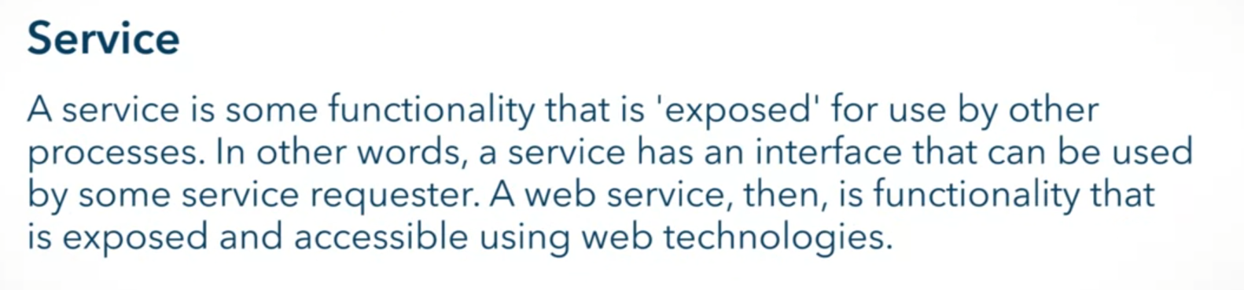

Before:

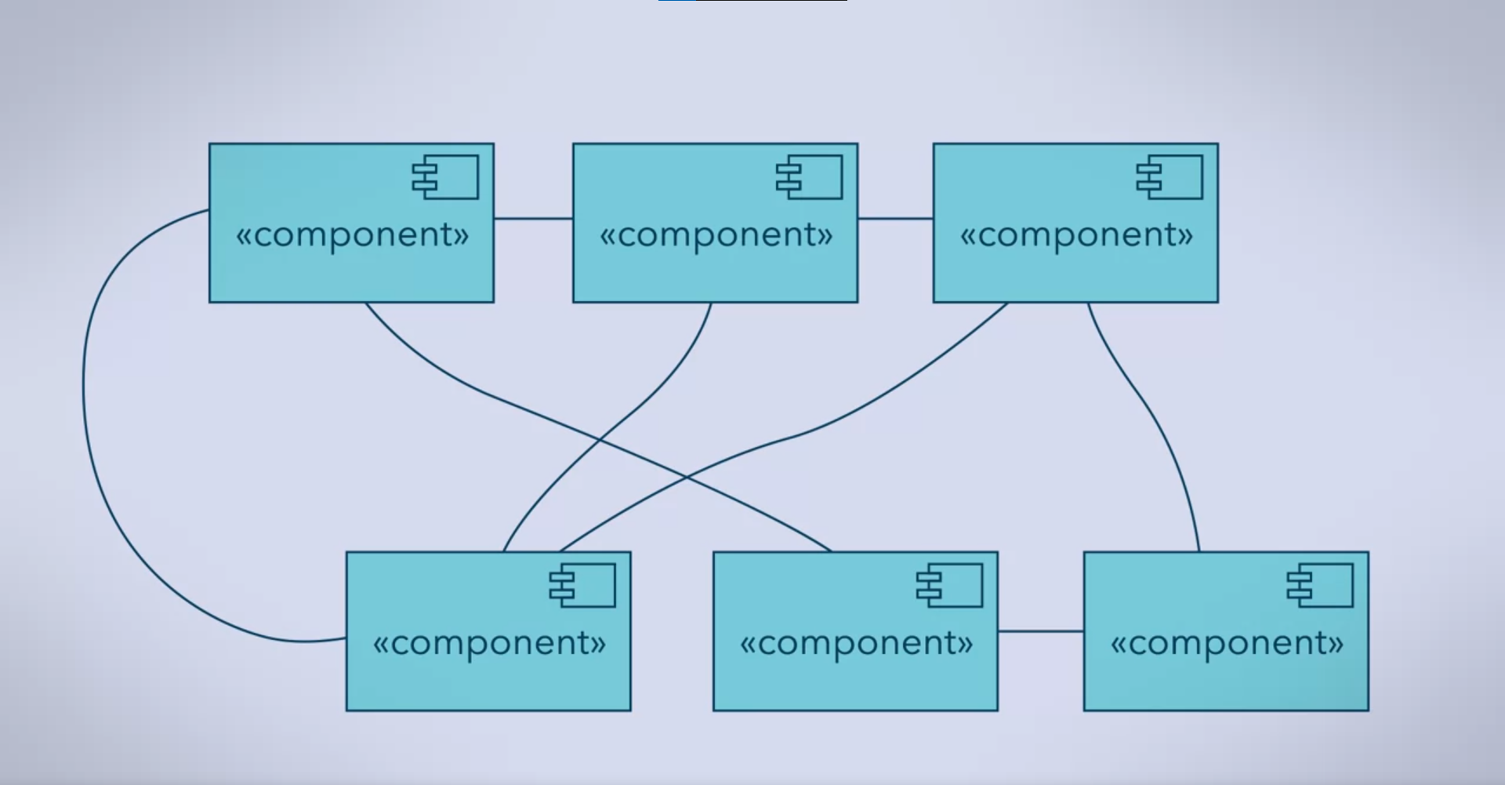

After:

* EAI (Enterprise Application Integration) is used

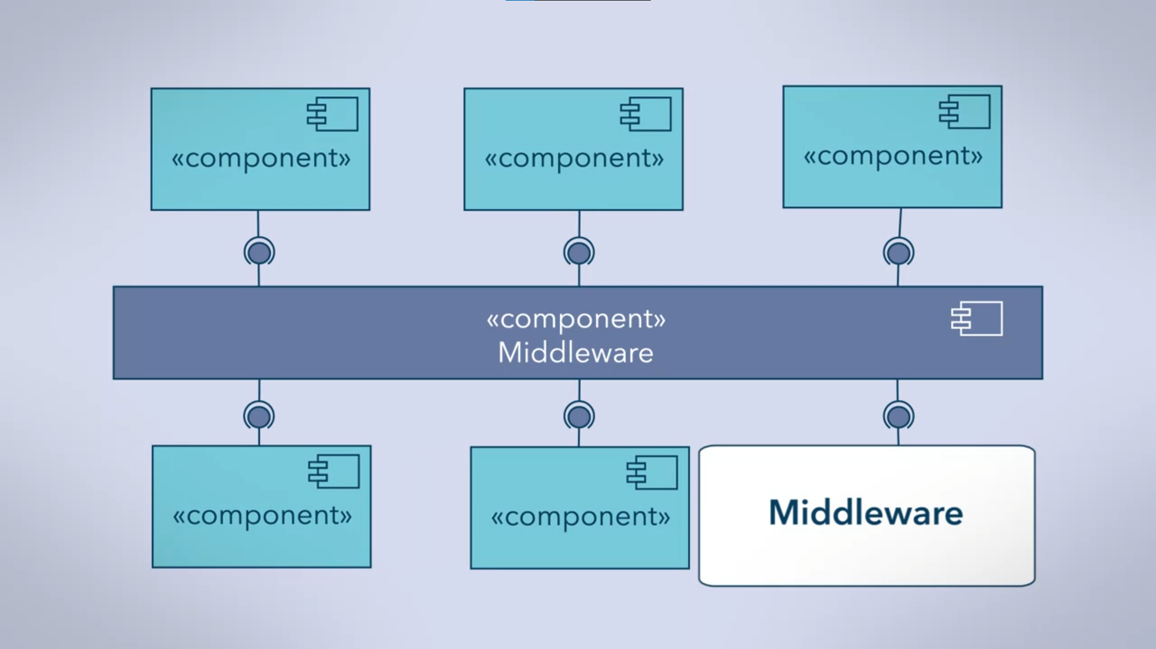

* The use of middleware
* But note that EAI is not used in B2B (Business to business) interactions
  + Reasons:
    - It’s not obvious where to put the middleware (hosting of the middleware)
    - Businesses want to keep control over their data
    - Security may be an issue
  + B2B uses Web Services instead

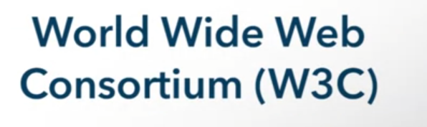

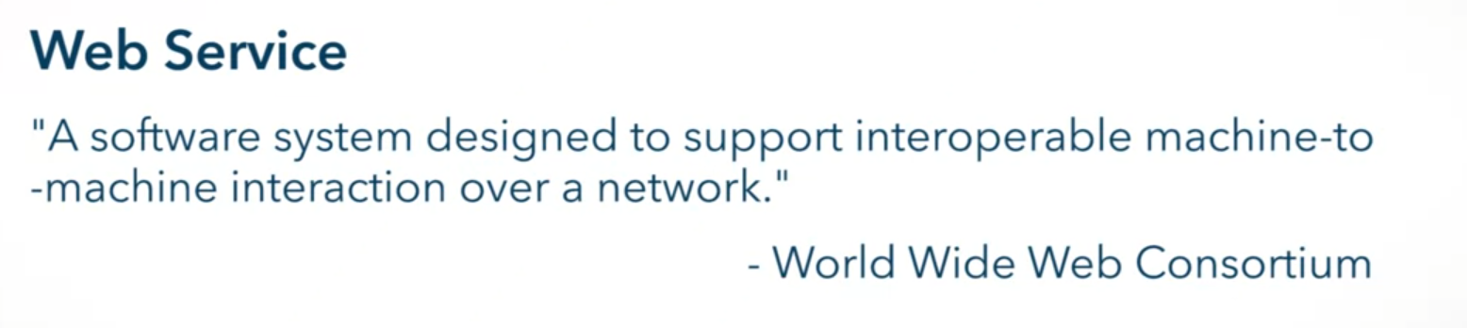

Standards of Web Services

* TCP
* HTTP

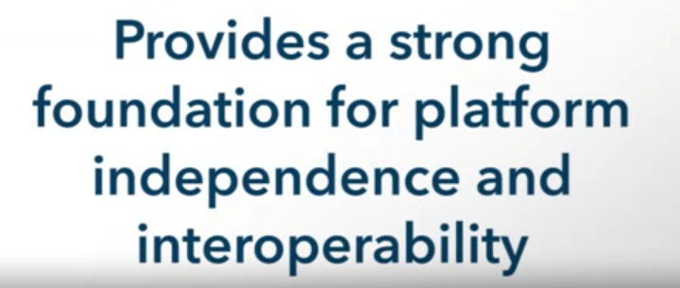



Service Requesters

Invoke

* Like a method call
* Done through a request
* Done with SOAP
  + Simple Object Access Protocol
  + Based on XML

Web Service Description Language (WSDL)

* Based on XML
* Used in binding

Service Providers

* Can publish descriptions of their services
* Use UDDI
  + Universal Description, Discovery, and Integration

3 foundational standards

* SOAP
  + For invoking web services
* WSDL
  + Specification for describing web services interface
* UDDI
  + Brings service providers and service requesters together by offering both publishing and discovery

Various Standards are built from these three

* With prefix WS
  + WS-Security
  + WS-Coordination
  + WS-BPEL

WS-BPEL

* Business Process Execution Language
* Allows combine existing services into new composite services

Service Composition

* Active combining of web services

